Vijay’s Assignment – Hive 2

Following steps performed

1. Input CSV file imported into HDFS under /hive folder
2. New table “olympics” created in HIVE using this SQL



Task 1

1. Write a Hive program to find the number of medals won by each country in swimming.



Output

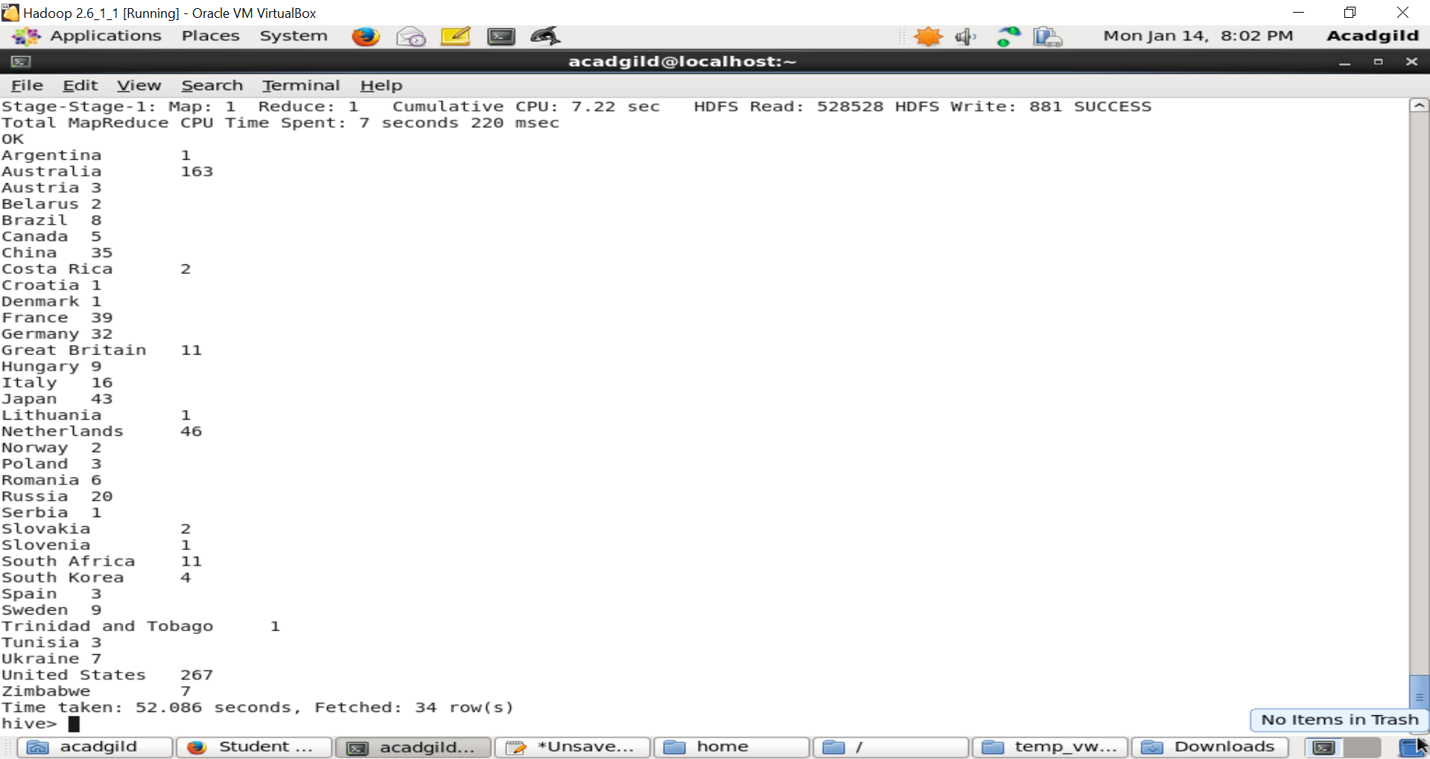

2. Write a Hive program to find the number of medals that India won year wise.

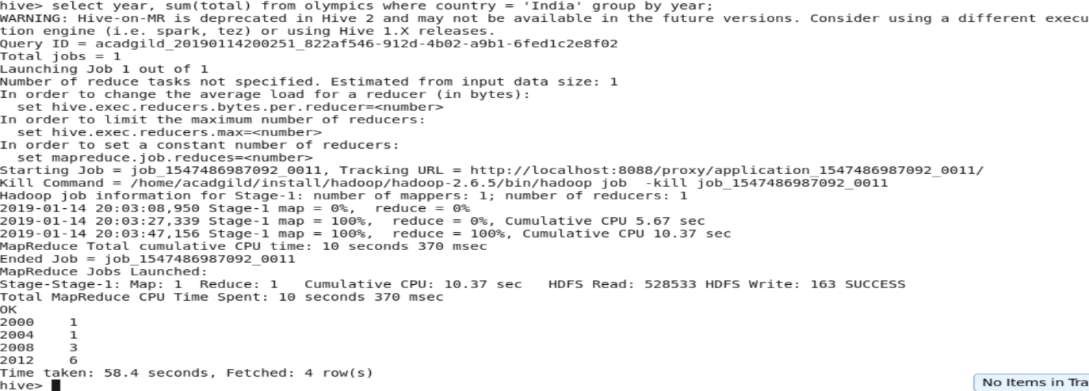

3. Write a Hive Program to find the total number of medals each country won.



Output

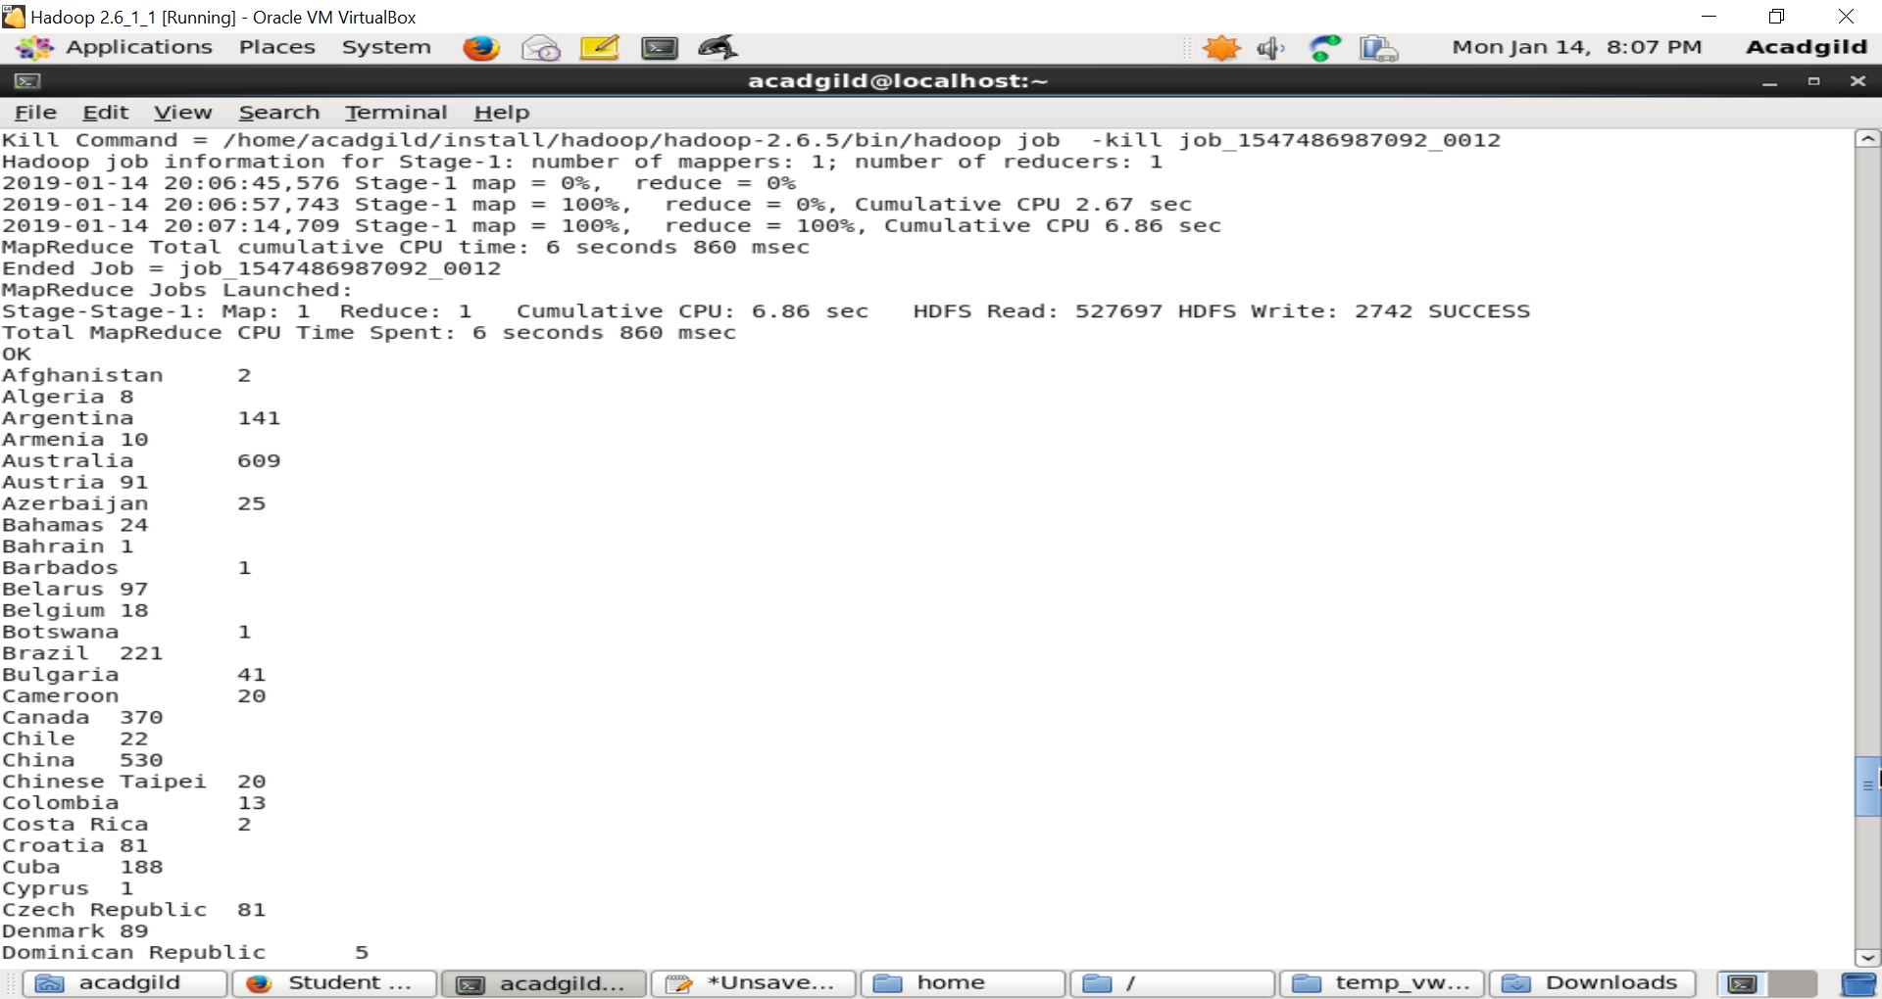

4. Write a Hive program to find the number of gold medals each country won.



Output

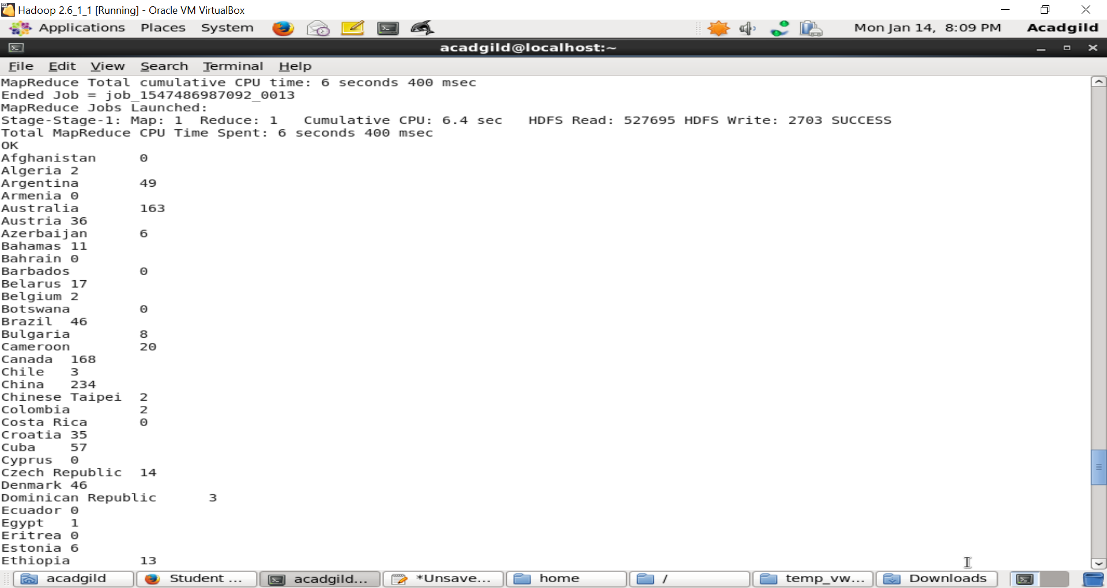

Task 2

Write a hive UDF that implements functionality of string concat_ws(string SEP, array<string>).

This UDF will accept two arguments, one string and one array of string.

It will return a single string where all the elements of the array are separated by the SEP.

Task 3

Link: https://acadgild.com/blog/transactions-in-hive/

Refer the above given link for transactions in Hive and implement the operations given in the

blog using your own sample data set and send us the screenshot.